Aldehyde Deuteration - Model Search - full dataset

### Model Search

| formula | McFadden R2 |
| --- | --- |
| class ~ dip_y + NPA_3 + diff 1 2 + loc.B5 | 0.633 |
| class ~ dip_y + NPA_1 + NPA_3 + loc.B5 | 0.631 |
| class ~ -2-3- + dip_y + Dist(2, 7) + NPA_1 | 0.626 |
| class ~ -2-3- + dip_y + NPA_3 + diff 1 2 | 0.626 |
| class ~ dip_y + Dist(2, 7) + NPA_3 + diff 1 2 | 0.615 |
| class ~ Total + NPA_3 + diff 1 2 + loc.B5 | 0.612 |
| class ~ dip_y + Dist(2, 7) + NPA_1 + NPA_3 | 0.611 |
| class ~ Total + NPA_1 + NPA_3 + loc.B5 | 0.611 |
| class ~ Total + diff 1 2 + diff 2 3 + loc.B5 | 0.610 |
| class ~ dip_y + NPA_3 + diff 1 2 + L | 0.607 |

### 1st Place

Table:

Full Model Stats - Overall Accuracy and Pseudo-R2

| Accuracy | McFadden_R2 |
| --- | --- |
| 87.27% | 0.633 |

Model Coefficients

|  | x |
| --- | --- |
| dip_y | -2.1731078 |
| NPA_3 | -301.0306563 |
| diff 1 2 | -45.1831292 |
| loc.B5 | -0.4137891 |

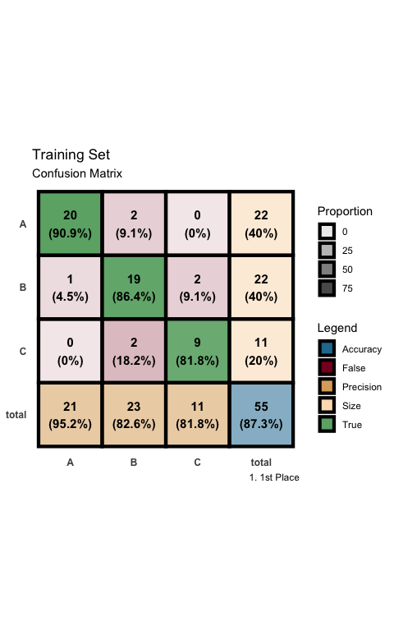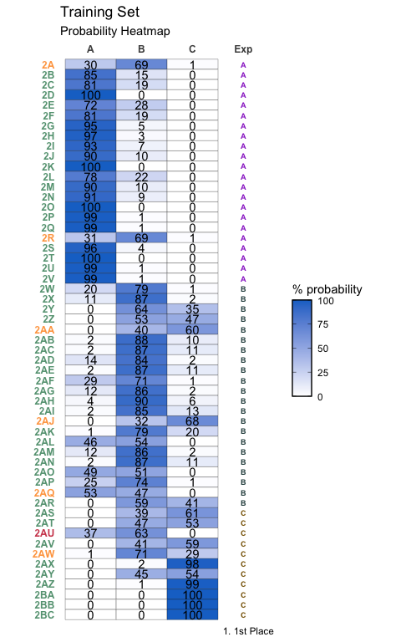

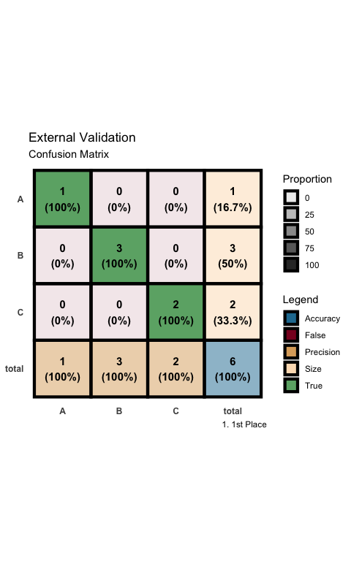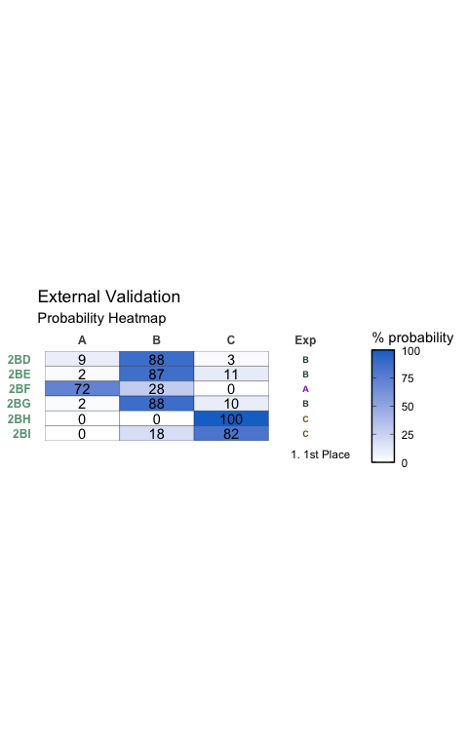

### 2nd Place

Table:

Full Model Stats - Overall Accuracy and Pseudo-R2

| Accuracy | McFadden_R2 |
| --- | --- |
| 85.45% | 0.631 |

Model Coefficients

|  | x |
| --- | --- |
| dip_y | -2.2317015 |
| NPA_1 | 44.8723551 |
| NPA_3 | -296.7042382 |
| loc.B5 | -0.4538779 |

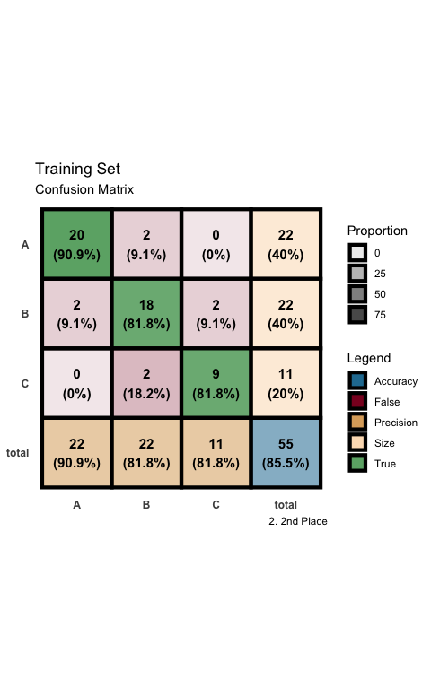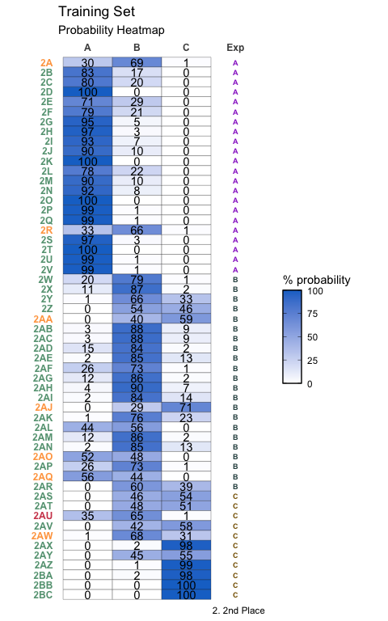

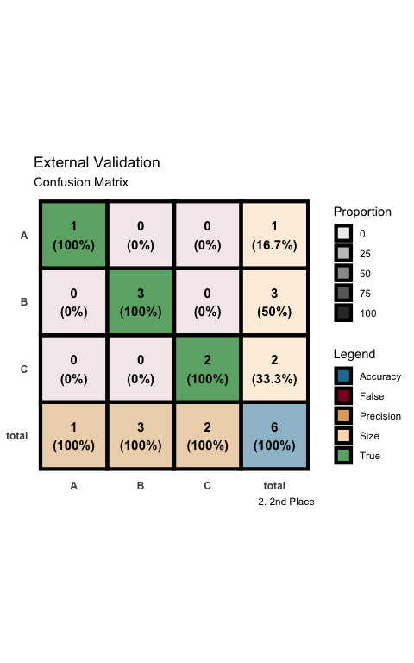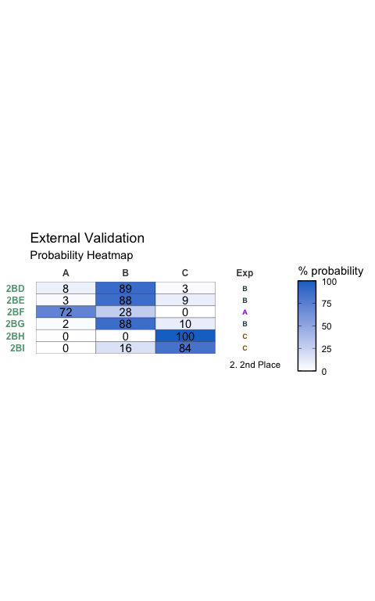

### 3rd Place

Table:

Full Model Stats - Overall Accuracy and Pseudo-R2

| Accuracy | McFadden_R2 |
| --- | --- |
| 89.09% | 0.626 |

Model Coefficients

|  | x |
| --- | --- |
| -2-3- | -0.4678155 |
| dip_y | -1.8657764 |
| Dist(2, 7) | 349.7731912 |
| NPA_1 | 56.0996610 |

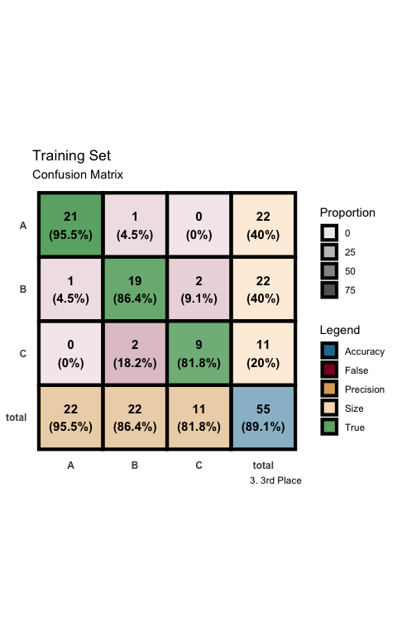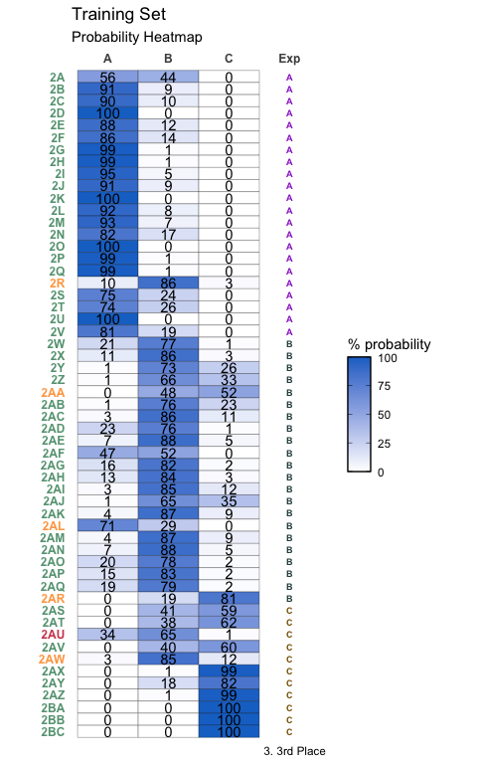

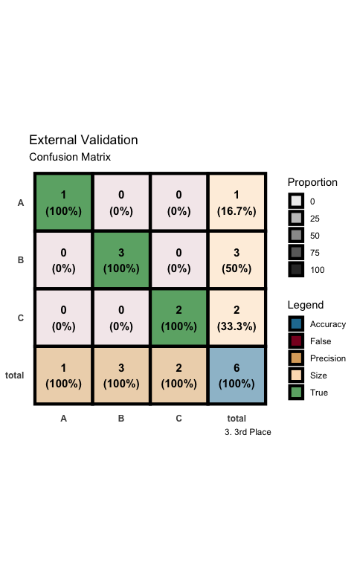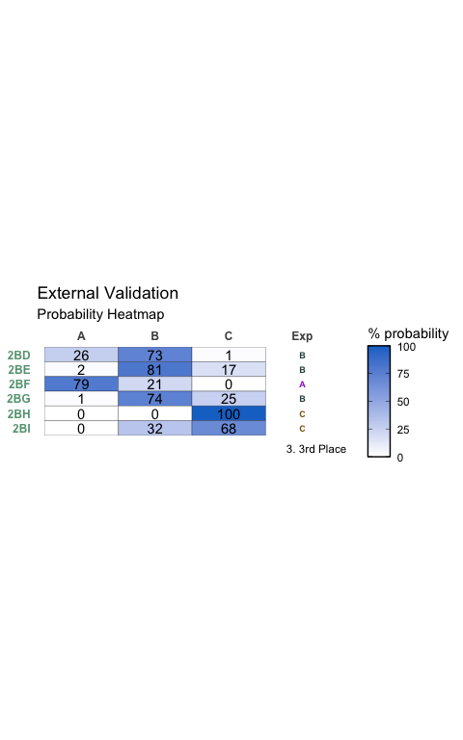

### 4th Place

Table:

Full Model Stats - Overall Accuracy and Pseudo-R2

| Accuracy | McFadden_R2 |
| --- | --- |
| 85.45% | 0.626 |

Model Coefficients

|  | x |
| --- | --- |
| -2-3- | -0.1274129 |
| dip_y | -1.5102414 |
| NPA_3 | -229.1140961 |
| diff 1 2 | -37.2903965 |

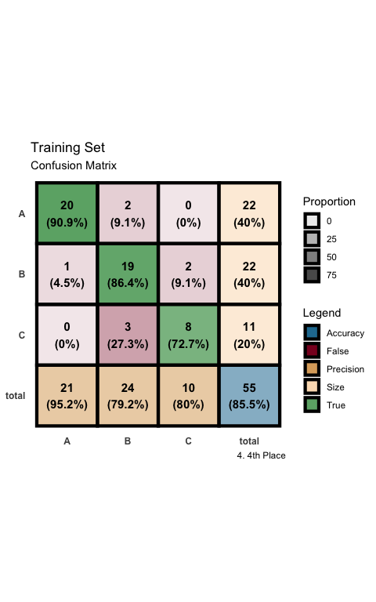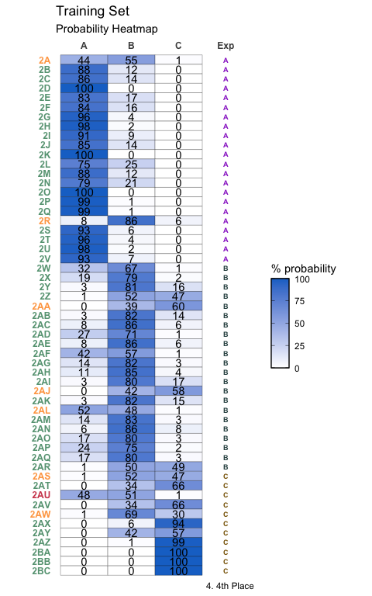

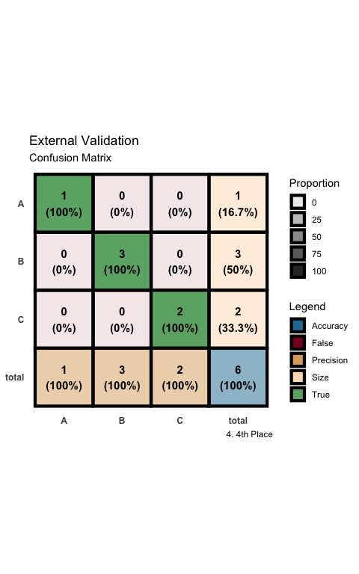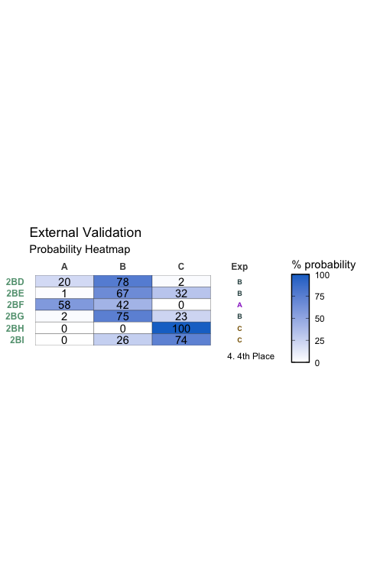

### 5th Place

Table:

Full Model Stats - Overall Accuracy and Pseudo-R2

| Accuracy | McFadden_R2 |
| --- | --- |
| 90.91% | 0.615 |

Model Coefficients

|  | x |
| --- | --- |
| dip_y | -1.312088 |
| Dist(2, 7) | -199.772943 |
| NPA_3 | -377.371537 |
| diff 1 2 | -40.854377 |

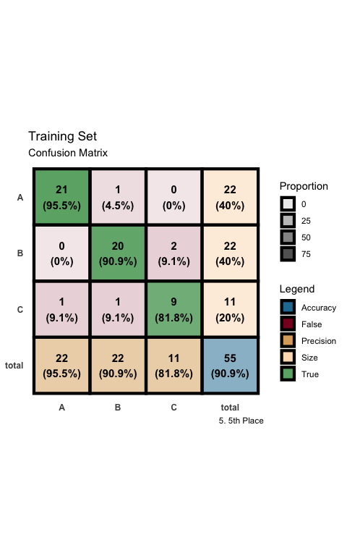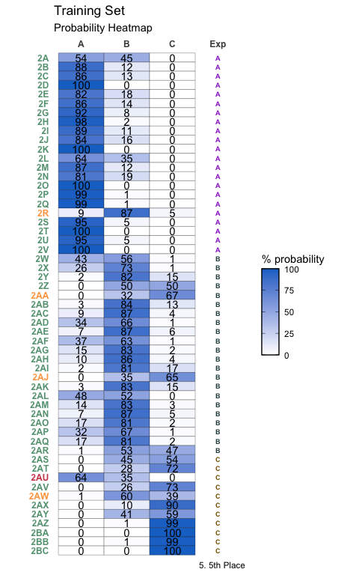

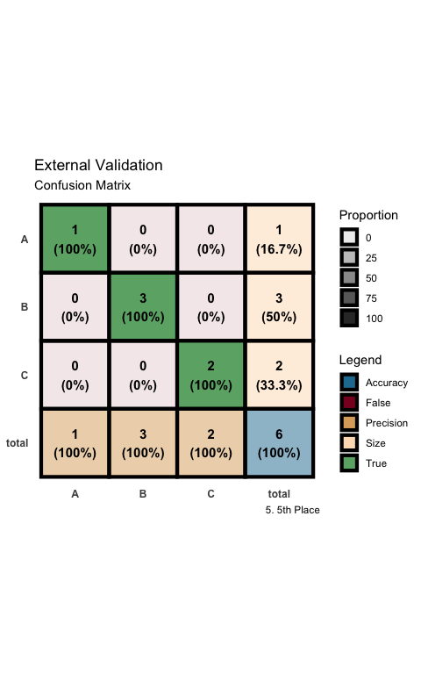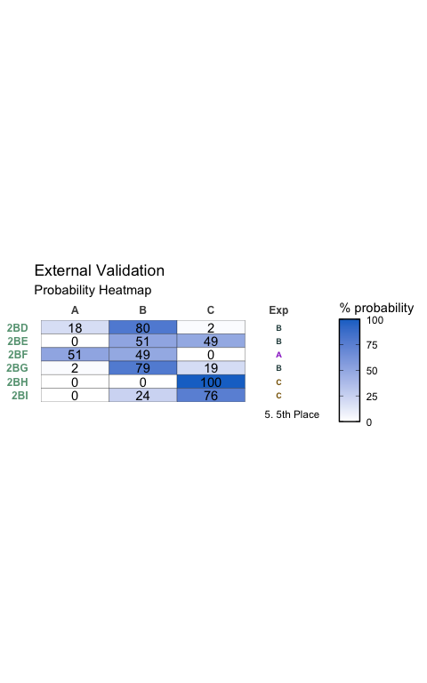

### 6th Place

Table:

Full Model Stats - Overall Accuracy and Pseudo-R2

| Accuracy | McFadden_R2 |
| --- | --- |
| 87.27% | 0.612 |

Model Coefficients

|  | x |
| --- | --- |
| Total | 2.0249154 |
| NPA_3 | -214.0491915 |
| diff 1 2 | -29.6819745 |
| loc.B5 | -0.4581857 |

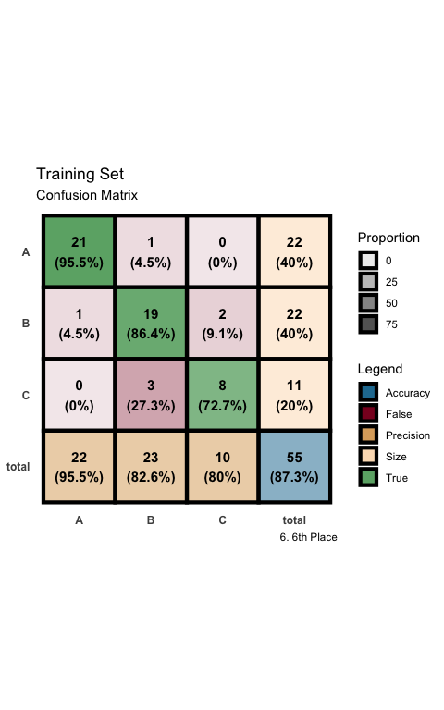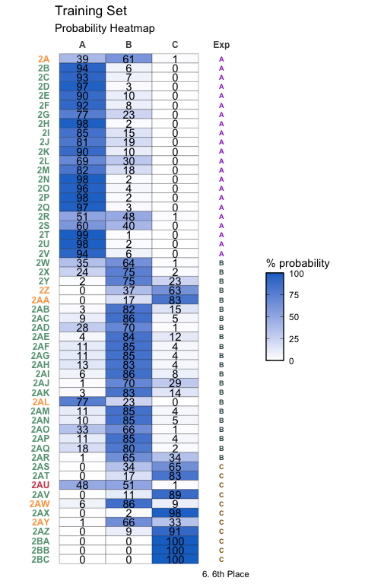

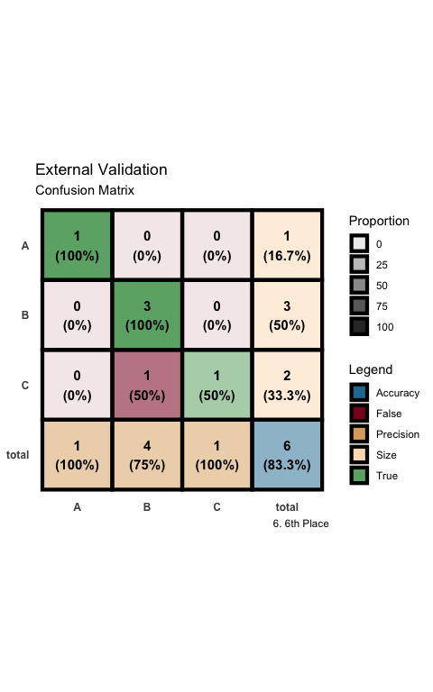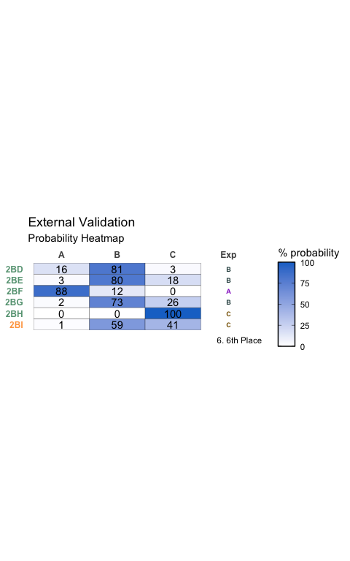

### 7th Place

Table:

Full Model Stats - Overall Accuracy and Pseudo-R2

| Accuracy | McFadden_R2 |
| --- | --- |
| 89.09% | 0.611 |

Model Coefficients

|  | x |
| --- | --- |
| dip_y | -1.445297 |
| Dist(2, 7) | -216.502286 |
| NPA_1 | 41.710705 |
| NPA_3 | -385.833684 |

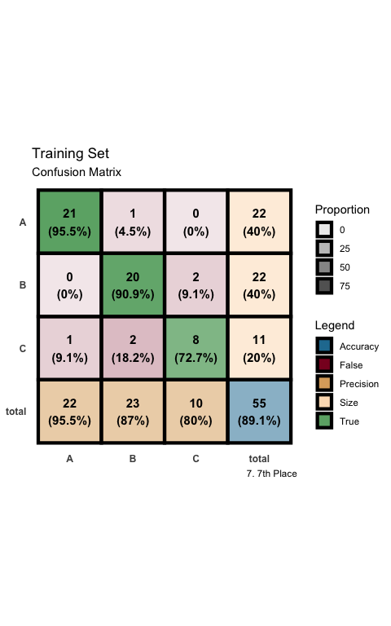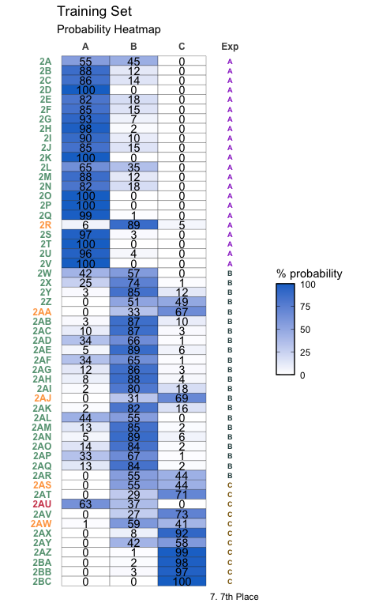

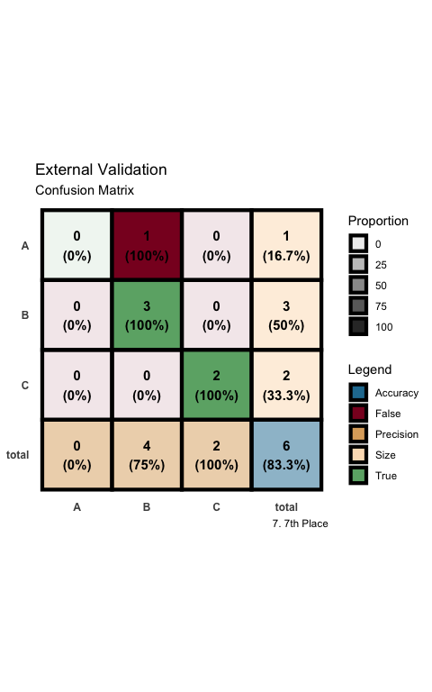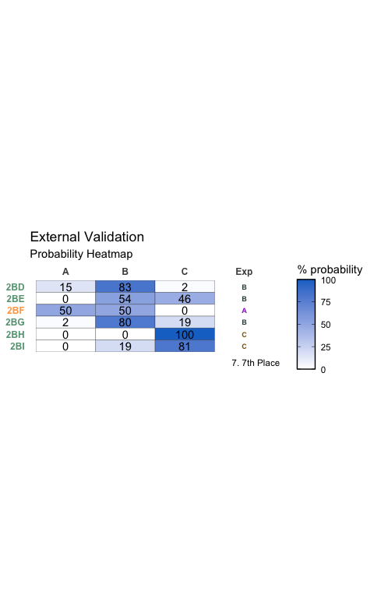

### 8th Place

Table:

Full Model Stats - Overall Accuracy and Pseudo-R2

| Accuracy | McFadden_R2 |
| --- | --- |
| 87.27% | 0.611 |

Model Coefficients

|  | x |
| --- | --- |
| Total | 2.103745 |
| NPA_1 | 28.211591 |
| NPA_3 | -185.424470 |
| loc.B5 | -0.488480 |

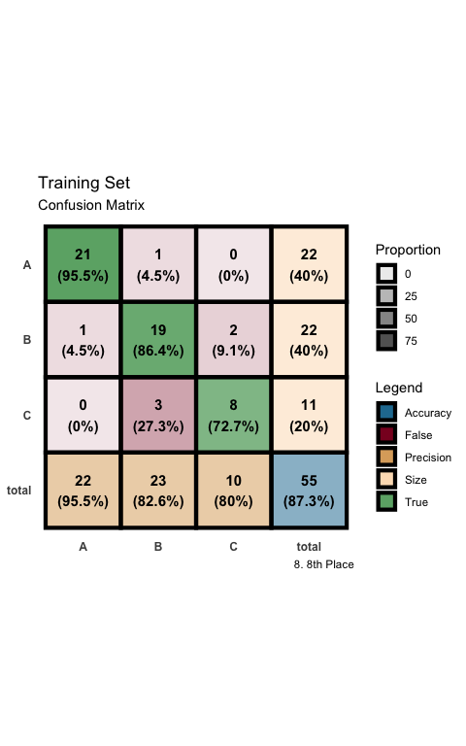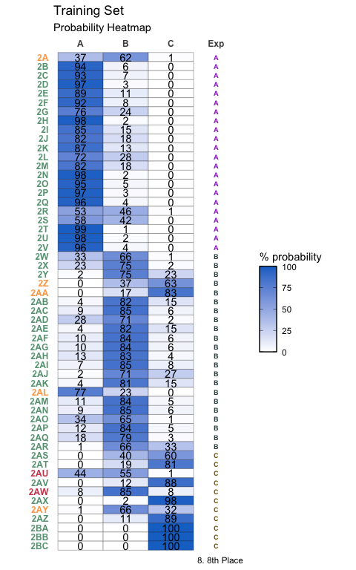

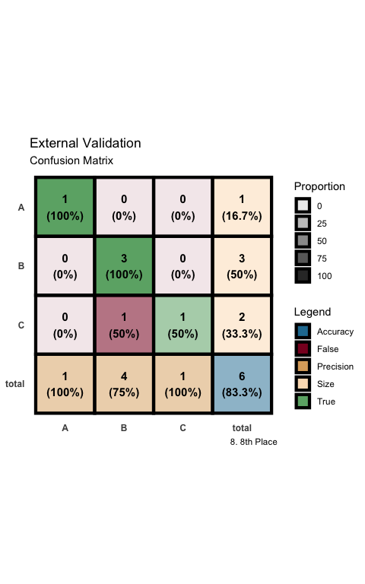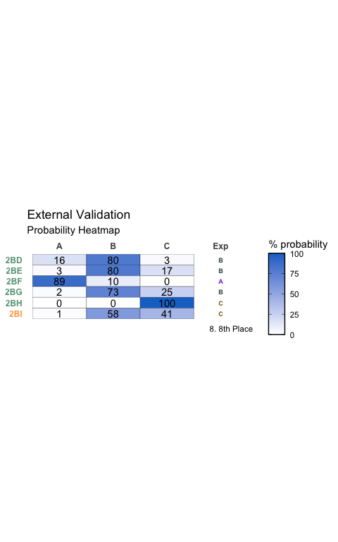

### 9th Place

Table:

Full Model Stats - Overall Accuracy and Pseudo-R2

| Accuracy | McFadden_R2 |
| --- | --- |
| 85.45% | 0.61 |

Model Coefficients

|  | x |
| --- | --- |
| Total | 2.5781439 |
| diff 1 2 | -35.1062475 |
| diff 2 3 | 186.6586708 |
| loc.B5 | -0.7037206 |

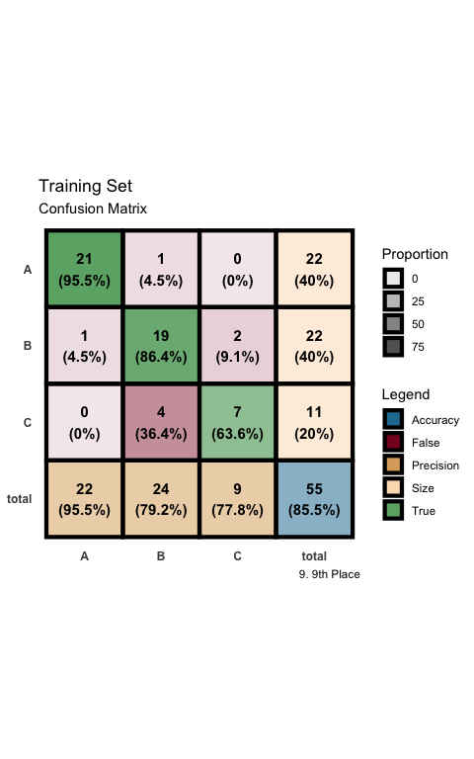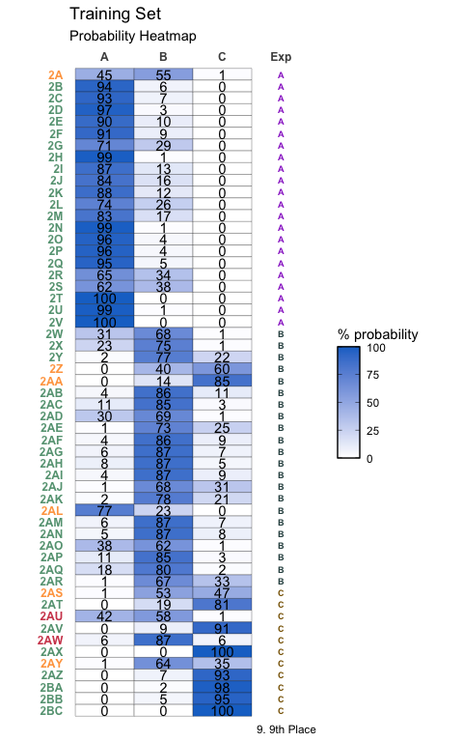

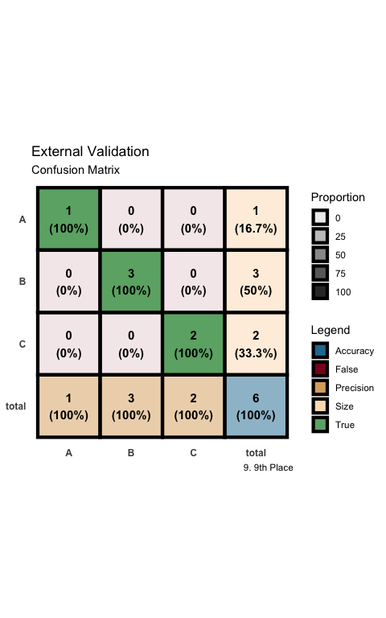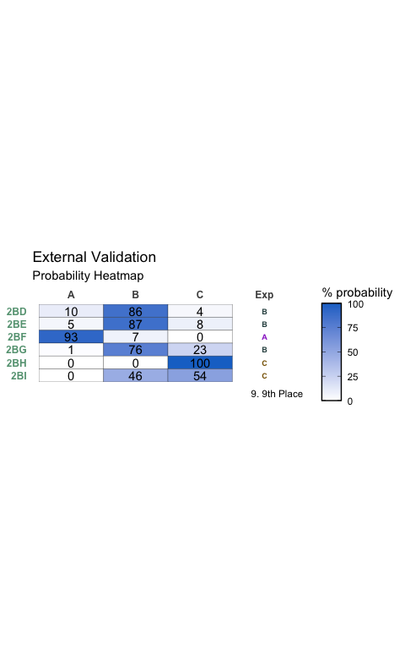

### 10th Place

Table:

Full Model Stats - Overall Accuracy and Pseudo-R2

| Accuracy | McFadden_R2 |
| --- | --- |
| 81.82% | 0.607 |

Model Coefficients

|  | x |
| --- | --- |
| dip_y | -2.2426235 |
| NPA_3 | -259.8157729 |
| diff 1 2 | -40.3407156 |
| L | -0.4205848 |

